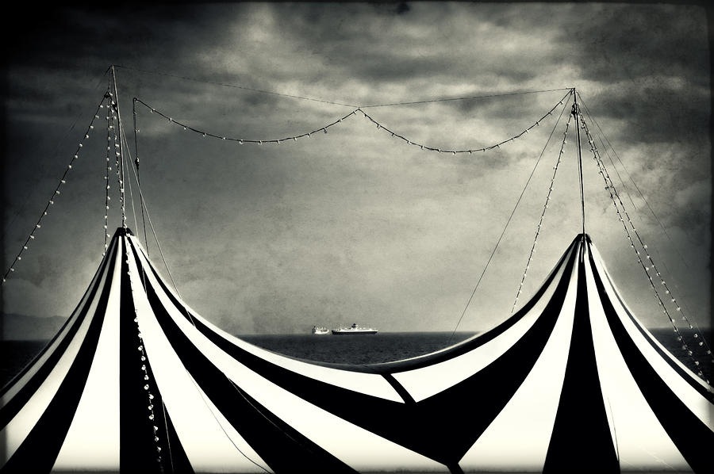
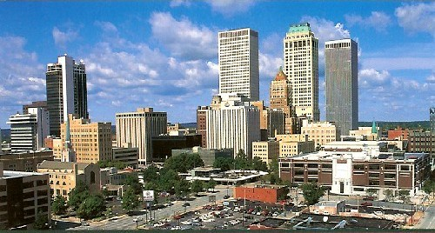
Green Country Swing
Ladies and Gentlemen!
Hurry, Hurry, Hurry!!!

Tulsa Community College (TCC) and Northeastern State University (NSU) proudly present this year’s Green Country Swing, under the Big Top of the Northeast Campus of Tulsa Community College on October 28, 29, 30. Featuring Novice and Varsity divisions of IPDA style debate, NFA-LD and all 11 AFA Individual Events, for your viewing and competition pleasure!

The Big Top is located at 3727 E. Apache (the corner of Harvard and Apache), just off Hwy 11, two miles west of the Tulsa International Airport. Registration is in the Academic Building on the West side of the campus. The two official hotels are located two miles from the tournament.
OCTOBER 28, 29, 30
RAIN OR SHINE!
Tulsa Community College NE Campus  3727 E. Apache  Tulsa, OK 74115 |  |  | Northeastern State University  609 N. Grand Ave.  Tahlequah, OK 74464
Tournament Contact:  Dr. Donna Goodwin  donna.goodwin@tulsacc.edu  (918) 510-2845 | Niki Alderson  Head Coach | Donna Landon  Assistant Coach | Kristopher Copeland  copela03@nsuok.edu  (918) 444-3627

Schedule

Flight A Events: (Poetry, POI, Impromptu, ADS, Inform, and Duo)

Flight B Events: (Extemp, Persuade, Comm. A., Dramatic Interp, and Prose)

Friday – October 28th  11:00-12:00 Registration  (Atrium 1st floor of Academic Building on West side of campus)  12:00-1:30: DRAW IPDA Round 1  1:30-3:00: DRAW IPDA Round 2  3:00-4:30: DRAW IPDA Round 3  4:30-6:00: DRAW IPDA Round 4  6:00-7:00 Dinner Break!!!  7:00-8:30 DRAW IPDA Round 5  8:00-9:30 DRAW IPDA Quarters | Saturday – October 29th  7:00-8:00: Registration  (Atrium 1st floor of Academic Building on West side of campus)  7:30: Draw IPDA Semifinals  8:30: Flight A Rd. I  9:45: Extemp Draw  10:00: Flight B Rd. I  11:15 Flight A Rd. II  12:00 DRAW IPDA Finals  12:30-1:15 Lunch)  1:00: Extemp Draw  1:15: Flight B Rd. II  2:30: Flight A Finals  3:45: Extemp Draw  4:00: Flight B Finals  Awards – ASAP | Sunday – October 30th  7:00-7:30 Registration  (Atrium 1st floor of Academic Building on West side of campus)  8:00 Extemp Draw  8:15: Flight B Rd. I and LD Rd. I  9:30: Flight A Rd. I and LD Rd. II  10:45 Flight A Rd. II and LD Rd. III  12:00-12:45 Lunch  12:30: Extemp Draw  12:45: Flight B Rd. II and LD Rd. IV  2:00: Flight A Finals and LD Semifinals  3:15: Extemp Draw  3:30: Flight B Finals and LD Finals  Awards – ASAP

***The tournament hosts reserve the right to make changes to the schedule as warranted.***

Entry Information
Submit all entries through Joy of Tournaments

Entry Deadline  ALL entries must be received through Joy of Tournaments  no later than 7:00 p.m.  on Monday, Oct. 24th.  Fees will be assessed upon your entry as it stands on Wednesday, Oct. 26th at 5pm.  ***All changes after that deadline will be assessed a nuisance fee. ***  Conflicting Entries  A student may only enter three events or less in each conflict pattern.  ***See notes on IPDA and LD for restrictions on debate/IE cross-entry.*** | Judges  1 judge covers 2 LD debaters, 4 IPDA debaters, or  6 IE entries  Judging Obligations:  Judges are obligated for one round after their team has been eliminated from  competition. A judge cannot cover LD and IE entries on Sunday.  We NEED your judges, not your money! | Payment Information  Please make POs and checks payable to:  TCC Forensics  Attn: Donna Goodwin  3727 E. Apache  Tulsa, OK 74115  FED ID # is: 73-6017987 | Fees  Entries  IPDA & LD - $35.00 each  IEs - $8.00 each  Uncovered Judges  IPDA /LD - $40.00 per entry  IEs- $12.00 per entry  Drop Fees  Fees will be assessed on Wednesday at 5:00 pm, any drop after that date (including at registration) will incur a drop fee of $15.00 per IE entry and $25.00 per debate entry.

DEBATE
***IPDA***
If your squad hasn’t tended to participate in IPDA debate, this tournament will be the best chance to test your team’s skills. We focus on substantial topics and make a substantial effort to bring in a pool of intelligent, conscientious, open-minded, and educationally productive judges so students receive fair, educational, high quality feedback.

There will be two divisions, Novice and Varsity.  The IPDA rules can be found at: http://www.ipdadebate.info  IPDA is growing in the region, but has limited availability in the Central States. It is our desire to help bring this event to our students to provide: easier integration to competitive debate, a testing ground for concise and effective persuasion in an efficiency-dependent form  Students will first meet at the same location as extemp draw to pick their topic. | There will be five topics, with the negative striking one, then the affirmative, then the Neg, then the Aff, and the last resolution will be debated. Students can then use any form of research with prep time lasting 30 minutes. Here is an example of a pre-round resolution sheet.  Sample IPDA Resolutions  - RE: Education should be privatized.  - RE: The IRS should be abolished.  - RE: America’s global leadership is ending.  - RE: A Friend to all is a friend to none.  - RE: Facebook makes us dumb. | Although IPDA is lax on prep materials, no printed evidence should be brought into the debate round. Use of evidence and common knowledge is similar to NPDA usage.  Judges for IPDA can be lay which include coaches, parents, IE students, Comm. students, anybody outside of high school. IPDA prides itself on having a diverse judging pool so that debaters must adapt to extremely varying paradigms. | IPDA time formats are as followed (No prep time in round – Draw 30 minutes before the round starts).  Affirmative Constructive 5 min  Cross Ex 2 min  Negative Constructive 6 min  Cross Ex 2 min  1st Aff Rebuttal 3 min  Neg Rebuttal 5 min  2nd Aff Rebuttal 3 min
***Lincoln Douglas ***

* For Sunday only (scheduling reasons,) Lincoln Douglas participants may not be cross-entered with any IE events except IPDA.
The 2016-2017 Lincoln Douglas debate resolution is:  Be it RESOLVED: the United States Federal Government should substantially reduce the role of the United States Southern Command in Latin America.  Much more information can be found on the NFA-LD website. | Format  4 min prep time per speaker  Affirmative Constructive 6 min  Cross Ex 3 min  Negative Constructive 7 min  Cross Ex 3 min  1st Aff Rebuttal 6 min  Neg Rebuttal 6 min  2nd Aff Rebuttal 3 min

Awards

Tulsa Portion  IEs: Top 6 finalists in each IE event  IPDA: Qtrs, Semis, and Finals  IPDA Speakers: (1st-4th)  Debate Sweepstakes  1st-3rd  IE Sweepstakes  1st-3rd  Combined Debate & IE Sweepstakes 1st-3rd  Community College  1st-3rd  Top Novice Competitor  Top Competitor | NSU Portion  IEs: Top 6 finalists in each IE event  LD: Qtrs, Semis, and Finals  LD Speakers: 1st-4th  Debate Sweepstakes  1st-3rd  IE Sweepstakes  1st-3rd  Combined Debate & IE Sweepstakes 1st-3rd  Community College  1st-3rd  Top Novice Competitor  Top Competitor | Cirque le Vert Swing (Combination of both tournaments awards)  Debate Sweepstakes  1st-3rd  IE Sweepstakes  1st-3rd  Combined Debate & IE Sweepstakes  1st-3rd  Community College Sweepstakes  1st-3rd  Novice Ringleader  Ringleader
Awards
The awards for individuals will be glass-framed awards. The awards for teams will be trophies. However, to keep with the theme, we will additionally include some fun circus awards for our winners.

Individual Sweepstakes

Top Competitor & Top Novice Competitor
For each half of the swing, a top competitor and Novice top competitor will be chosen.
To enter students must be entered in at least 4 events with at least one event in each area:
IPDA Debate, Limited Prep (Extemp or Impromptu), Platform Speech (Comm. A, Inform, Persuade, or ADS), and Interp Events (Prose, Poetry, POI, Dramatic Interp, or Duo).

Ringleader & Novice Ringleader
On Sunday a combined top competitor award for the entire swing will be given.
To enter students must be entered in at least 4 events with at least one event in each area:
IPDA Debate, LD Debate, Limited Prep (Extemp or Impromptu), Platform Speech (Comm. A, Inform, Persuade, or ADS), and Interp Events (Prose, Poetry, POI, Dramatic Interp, or Duo).

Team Sweepstakes
We will award sweepstakes trophies to the top three schools in the following categories: Debate, IEs, Combined Debate & IEs, and Community College Sweeps, for both halves of the swing in addition to the same trophies for the entire swing.

Sweepstakes Formula:

 | Debate (IPDA or LD) | IEs
Prelims | 4 pts. for a win or bye  0 pts. for a loss | 3 points for a ranking of 1  2 points for a ranking of 2  1 point for a ranking of 3
Outrounds/Finals | Champion- 24,  Finalist- 20  Semifinalist -16  Quarterfinalist -8 | 6 points for 1st  5 points for 2nd  4 points for 3rd  3 points for 4th  2 points for 5th  1 point for 6th
Speaker | 6 points for 1st  5 points for 2nd  4 points for 3rd  3 points for 4th  2 points for 5th  1 point for 6th
Meals
Pizza and drinks will be provided for all competitors, judges, and coaches on Friday evening.
All schools will have the option to order a box lunch for their team, coaches, and judges for lunch on Saturday and Sunday. You will fill out the lunch purchase within your entry with joyoftournaments. More information will be provided on these meals at a later date.

Hotel Information
*Official Tournament Hotels
* Clarion Inn  Tulsa Airport | * Hilton Garden Inn  Tulsa Airport | Super 8  (I-44 & Memorial)
2201 N. 77th E. Ave  (off Highway 11)  Tulsa, OK 74115  (918) 835-9911  $72.00 (4 adults) + tax  Free Breakfast  Block of 18 non-smoking Queen Rooms held until October 20th.  Reservation name:  Green Country Swing  If further questions you can ask for Cammy | 7728 E. Virgin Court  (off Highway 11)  Tulsa, OK 74115  (918) 838-1444  EXT: 5015  $99.00 + tax  2 Double Beds  Cook to order Breakfast  Block of 20 Rooms  held until Oct. 21st.  Reservation name:  TCC/Green Country Swing  If further questions you can ask for Stella | 3211 S 79th East Ave.  Tulsa, OK  (918) 660-8080  $69.00 + tax  2 Double Beds  Continental Breakfast

