

**2014 Gulf Coast Swing**

January 16, 2014

Dear IPDA Colleagues:

The College of the Mainland Debate Team/Texas Alpha Omicron Chapter of Pi Kappa Delta and the Lee College Debate Team proudly invite you to be a part of the 2014 Gulf Coast Swing IPDA Debate Tournament held on the College of the Mainland campus March 21-23, 2014. This swing will consist of two separate individual IPDA tournaments held the same weekend on the College of the Mainland campus.

We will proudly offer all three divisions of IPDA. Due to classroom space limitations, the tournament is open to the first 32 Novice, 32 Varsity, and 16 Professional competitors. Adjustments may be made to these division caps if necessary and if possible based on the number of entries. Bob Alexander will be running tab at this year’s swing tournament

Entries must be received by Tuesday, March 18, 2014 at 4PM. Changes may be made to entries prior to Wednesday, March, 19, 2014 at 4PM. Please see the Registration Form included in this invitation packet. Fees for the tournament are $25 per covered entry and $40 per uncovered entry. We accept cash or checks only - no credit cards please. Make checks payable to “College of the Mainland Pi Kappa Delta” or “COM PKD” for entries to the Duck Debates, the first half of the swing held on Friday afternoon through Saturday afternoon and to “Lee College Debate” for the Lee College Rebel Debates for entries in the second half of the tourney, held Saturday afternoon through Sunday afternoon. Please provide a sufficient number of judges! One judge will cover up to four (4) competitors.

This is an excellent opportunity for your team to earn some last minute points and/or practice as it is the last tournament prior to IPDA Nationals! Come enjoy the hospitality of Texas City and College of the Mainland, located about 30 minutes south of Houston, TX. While you are here, take a moment to enjoy what the coast has to offer as we are located a mere 15 minutes from the beaches of Galveston Island!

Sincerely,

|  |  |
| --- | --- |
| **Duck Debates**  Nakia Welch, PhD  Assistant Professor  College of the Mainland  1200 Amburn Rd.  Texas City, TX 77591  409.933.8120  [debate@com.edu](mailto:debate@com.edu) | Joe Ganakos, M.A.  Director of Forensics  Lee College  P.O. Box 818  Baytown, TX  77522  281.425.6502  [jganakos@lee.edu](mailto:jganakos@lee.edu) |

**Registration**

* The entry deadline is Tuesday, March 18, 2014 at **4PM**.
* Please email entries to the appropriate program (see registration forms on pages 6 & 7 of this invite)
* Registration fees are $25 per covered entry (1 judge covers 4 debaters) and $40 for each uncovered entry.
* Changes to entries will be accepted at no charge until Wednesday, March 19th at 5PM – after which drops or changes may incur a $10 fee per alteration; any changes occurring on the day of registration will be subject to applicable nuisance fees for reflighting/rescheduling the rounds.
* We accept cash or checks (payable to College of the Mainland Pi Kappa Delta (COM PKD) and/or Lee College Debate) for entry fees.
* Due to classroom space limitations, we will be limiting entries to the first 32 Novice, 32 Varsity, and 16 Professional competitors; divisions may be expanded/reduced based on entry need.
* WiFi access is available throughout much of the campus. To log-in, connect your wireless-enabled device to the **COM-Wireless AP** connection, then open your web browser. The web browser will direct the device to a webpage with terms and agreements – you will need a valid email address in order to connect to the wireless network.
* Information about the Duck Debates is also available on the Guidebook App.

**Protocols**

* Programs may enter as many competitors as it wishes (space permitting) within the three divisions – Novice, Varsity, and Professional. If you have questions concerning division eligibility, please refer to the IPDA constitution at [www.ipdadebate.info](http://www.ipdadebate.info).
* Time format will be 5-2-6-2-3-5-3 with 30 min. of preparation between draw and the start of each round.
* Rounds will be flighted.
* The tabulation room will be closed until Round 6 – Flight A debate has begun.
* Competitors in all three rounds will earn one (1) point per preliminary round win, one (1) point for breaking to the elimination rounds, and two (2) points per elimination round win.
* Each program may accumulate sweepstakes points for the top four (4) competitors entered in each division.
* All programs are required to be available to judge one round beyond their highest elimination round.
* Competitors who do not advance may be used as judges in elimination rounds.
* Draw and prep will take place in the Student Center
* Debate rounds will take place in classrooms located in the Learning Resources Center (LRC) Math & Science (MS), and Technical Vocational Building (TVB).
* Maps of all buildings will be provided upon arrival and will be available on the Guidebook App.

**Food**

* There are a variety of restaurants located near campus; refer to the ***Eat-Stay-Play*** guide at <http://www.texascitychamber.com/> for restaurant information.
* Restaurant guides will be provided at the tournament for nearby tourist areas Galveston Island and League City/Webster (near Johnson Space Center).
* Breakfast is available at the tournament hotels (see information above).

**Accommodations**

* There are two designated tournament hotels, the Fairfield Inn and the Hampton Inn located within a couple of miles of the campus (see map below).
* 15 rooms have been reserved for $79/night at the Fairfield Inn and 15 rooms have been reserved at the Hampton Inn at a rate of $85/night

|  |  |
| --- | --- |
| **Fairfield Inn Texas City**  **10700 Emmitt F. Lowry**  **Texas City, TX 77591**  **409.986.3866** | **Hampton Inn Texas City**  **2320 FM 2004**  **Texas City, TX 77591**  **409.986.6686** |

* Both hotels offer breakfast, indoor pool and spa, workout facilities, and free WiFi.
* You must reserve your rooms by 5pm, February 21, 2014 to guarantee room availability.
* When making reservations, mention that you will be attending the College of the Mainland Debate Tournament to ensure you receive the discounted rate-first come, first served.
* If the tournament hotels are not available, other accommodations can be found in the Eat-Stay-Play guide at <http://texascitychamber.com>.

C:\Users\Patricia\AppData\Local\Microsoft\Windows\Temporary Internet Files\Content.IE5\7SKIEZZM\MC900329243[1].wmf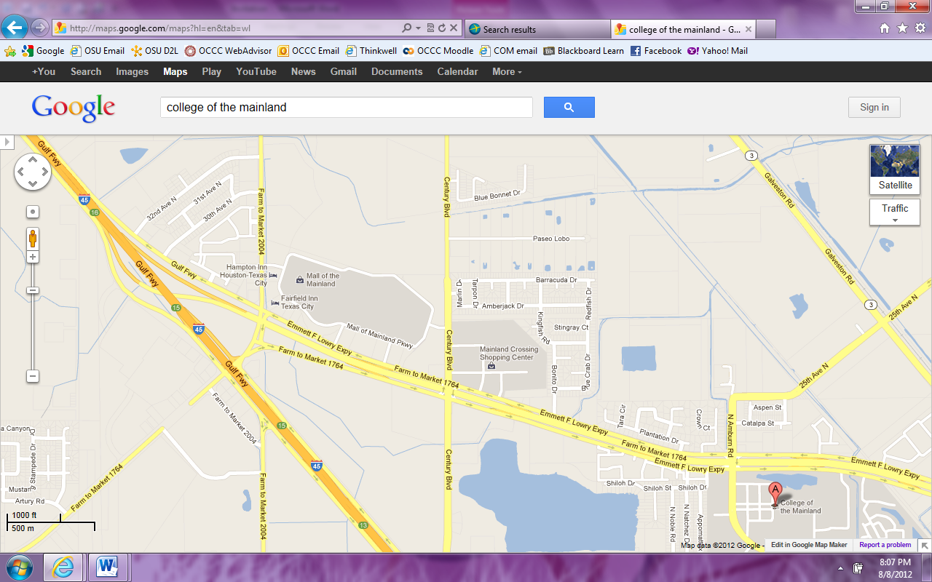

**Awards**

|  |  |
| --- | --- |
| **Duck Debates Awards** | **Lee College Awards** |
| * Awards for the top 5 speakers in each division * All elimination round competitors will earn awards. * The top 3 programs will earn a *Sweepstakes* team award (based on points earned in the six pre-elimination rounds-see point calculations above), the team with the highest winning percentage (with a minimum of 3 competitors, all competitors for a program computed) will earn the *Per Centum Award*, and the *Top Community College* will receive an award. * The College of the Mainland debate team will not be considered for any team awards. | * Awards for the top 5 speakers in each division. * All elimination round competitors will earn awards. * The top 3 programs will earn a *Sweepstakes* team award (based on points earned in the six pre-elimination rounds-see point calculations above), the team with the highest winning percentage (with a minimum of 3 competitors, all competitors for a program computed) and the *Top Community College* will receive an award. * Should any LC Debaters be in the draw the Lee College Team will not be considered for any team awards. |

**Directions**

**Direction to College of the Mainland:**

* Traveling South on I-45, take the Emmett F. Lowry Expressway exit (Exit 16) on the right (see map above).
* Follow the Emmett F. Lowry Expressway (FM 1764) into Texas City.
* Take the Amburn Rd. exit on the right.
* Turn Right onto Amburn Rd.
* Take the first Left available entrance into campus to Parking Lot A (see campus map below)

**Parking:**

* There is no charge for parking and no parking permit required.
* Parking Lot A (as shown below) allows the easiest access in and out of the campus.
* Do not pull through the parking spaces facing incoming traffic; park in the direction of the parking spot or you may receive a parking ticket!

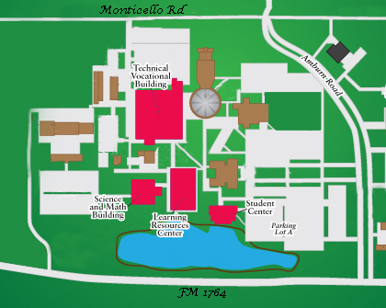

**Schedule**

|  |  |
| --- | --- |
| **Friday** | |
| 12:00-12:30 | Registration COM Swing Part I |
| 12:30-2:00 | Round 1 |
| 2:00-3:30 | Round 2 |
| 3:30-5:00 | Round 3 |
| 5:00-6:30 | Round 4 |
| 6:30-8:00 | Round 5 |
| 8:00-9:30 | Round 6  (Early coaches review begins during Round 6) |

|  |  |
| --- | --- |
| **Saturday** | |
| 7:30-7:45 | Coaches Review continued |
| 8:00-9:00 | Elimination 1 Octofinals and/or Quarterfinals |
| 9:00-9:30 | AWARDS |
| 9:30-10:40 | Elimination 2 Quarterfinals and/or Semifinals |
| 10:40-11:50 | Elimination 3  Semifinals and/or Finals |
| 11:50-1:00 | Elimination 4 (if necessary) Finals |
| LUNCH BREAK/Registration Lee College Swing Part II |
| 1:00-2:30 | Round 1 |
| 2:30-4:00 | Round 2 |
| 4:00-5:30 | Round 3 |
| 5:30-7:00 | Round 4 |
| 7:00-8:30 | Round 5 |
| 8:30-10:00 | Round 6 (Early coaches review begins during Round 6) |

|  |  |
| --- | --- |
| **Sunday** | |
| 9:00-9:15 | Coaches Review |
| 9:30-10:45 | Elimination 1 Octofinals and/or Quarterfinals |
| 10:45-11:15 | AWARDS |
| 11:15-12:30 | Elimination 2 Quarterfinals and/or Semifinals |
| 12:30-1:45 | Elimination 3  Semifinals and/or Finals |
| 1:45-3:00 | Elimination 4 (if necessary) Finals |

**Acknowledgements**

|  |  |
| --- | --- |
| College of the Mainland Pi Kappa Delta / Debate Team would like to thank the following for their contributions to the success of this tournament:   * Patricia McGee-Welch * The College of the Mainland Administration * The College of the Mainland Humanities Department Faculty | Lee College Debate Team would like to thank the following for their contributions to the success of this tournament:   * Lee College President Dennis Brown, Administration, and the Lee College Board of Regents * Lee College Division of Speech Communication, Languages & Teacher Education |

|  |  |
| --- | --- |
| **2014 Gulf Coast Swing** | **Duck Debates**  **March 21-22** |

Entries must be received by **4 PM**, Tuesday, March 18, 2014.

Fees for changes to entries assessed after **4 PM**, Wednesday, March 19, 2014.

E-Mail all registration forms to [debate@com.edu](mailto:debate@com.edu)

Make check payable to **College of the Mainland Pi Kappa Delta**

|  |  |  |  |
| --- | --- | --- | --- |
| **School Name:** |  | **Phone #:** |  |
| **Contact Name:** |  | **E-Mail:** |  |

|  |  |  |  |
| --- | --- | --- | --- |
| **Judge** | **Competitor Name** | **Division** | **Fee** |
|  |  |  |  |
|  |  |  |
|  |  |  |
|  |  |  |
|  |  |  |  |
|  |  |  |
|  |  |  |
|  |  |  |
|  |  |  |  |
|  |  |  |
|  |  |  |
|  |  |  |
|  |  |  |  |
|  |  |  |
|  |  |  |
|  |  |  |
| **Late Entry Changes** |  | |  |
|  |  | **Total Due** |  |

|  |  |
| --- | --- |
| **2014 Gulf Coast Swing** | **March 22-23** |

Entries must be received by **4 PM**, Tuesday, March 18, 2014.

Fees for changes to entries assessed after **4 PM**, Wednesday, March 19, 2014.

E-Mail all registration forms to [jganakos@lee.edu](mailto:jganakos@lee.edu)

Make check payable to **Lee College Debate**

|  |  |  |  |
| --- | --- | --- | --- |
| **School Name:** |  | **Phone #:** |  |
| **Contact Name:** |  | **E-Mail:** |  |

|  |  |  |  |
| --- | --- | --- | --- |
| **Judge** | **Competitor Name** | **Division** | **Fee** |
|  |  |  |  |
|  |  |  |
|  |  |  |
|  |  |  |
|  |  |  |  |
|  |  |  |
|  |  |  |
|  |  |  |
|  |  |  |  |
|  |  |  |
|  |  |  |
|  |  |  |
|  |  |  |  |
|  |  |  |
|  |  |  |
|  |  |  |
| **Late Entry Changes** |  | |  |
|  |  | **Total Due** |  |