



**2015 Duck Debates**

September 15, 2014

Dear IPDA Colleagues:

The College of the Mainland Debate Team/Texas Alpha Omicron Chapter of Pi Kappa Delta proudly invites you to be a part of the 2015 Duck Debates IPDA Debate Tournament held on the College of the Mainland campus March 6-7, 2015. This tournament will consist of one **nine** round individual IPDA tournament held on the College of the Mainland campus.

We will proudly offer all three divisions of IPDA (Novice, Varsity, and Professional). Due to classroom space limitations, there *may* be limitations to entries as we can comfortably accommodate about 80-100 competitors for the tournament, so entries will be honored on a first-come, first-served basis. This has never been a problem in past tournaments but it is worth mentioning.

Entries must be received by Tuesday, March 3, 2015 at 4PM. Changes may be made to entries prior to Wednesday, March, 4, 2015 at 4PM. Please see the Registration Form included in this invitation packet. Fees for the tournament are $30 per covered entry and $45 per uncovered entry. Please note the small increase in registration cost; this will be used to provide pizza, dessert, and drinks to all competitors, judges, and coaches on Friday evening. We accept cash or checks only for entries- no credit cards please. Make checks payable to “College of the Mainland Pi Kappa Delta” or “COM PKD.” Please provide a sufficient number of judges! One judge will cover up to four (4) competitors.

This is an excellent opportunity for your team to earn some late season points and/or practice before IPDA Nationals! Come enjoy the hospitality of Texas City and College of the Mainland, located about 30 minutes south of Houston, TX. As this is a Friday/Saturday only tournament, while you are here, take a moment to enjoy what the coast has to offer as we are located a mere 20 minutes from NASA’s Johnson Space Center and the sunny beaches of Galveston Island!

Sincerely,



Nakia Welch, PhD

Assistant Professor

College of the Mainland

1200 Amburn Rd.

Texas City, TX 77591

409.933.8120

[debate@com.edu](mailto:debate@com.edu)

**Registration**

* The entry deadline is Tuesday, March 3, 2015 at **4PM**.
* Please email entries to the appropriate program (see registration form on last page of this invite)
* Registration fees are $30 per covered entry (1 judge covers 4 debaters) and $45 for each uncovered entry.
* Changes to entries will be accepted at no charge until Wednesday, March 4 at 5PM.
* We accept cash or checks (payable to College of the Mainland Pi Kappa Delta (COM PKD)) for entry fees.
* WiFi access is available throughout much of the campus. To log-in, connect your wireless-enabled device to the **COM-GUEST** connection, then open your web browser. The web browser will direct the device to a webpage with terms and agreements – you will need to accept the terms in order to connect to the wireless network. Please be aware that internet service is not guaranteed as technology failures have been known to occur in the past. We offer our apologies for the inconvenience if it occurs.

**Protocols**

* Programs may enter as many competitors as it wishes (space permitting) within the three divisions – Novice, Varsity, and Professional. If you have questions concerning division eligibility, please refer to the IPDA constitution at [www.ipdadebate.info](http://www.ipdadebate.info).
* Time format will be 5-2-6-2-3-5-3 with 30 min. of preparation between draw and the start of each round.
* Rounds will be flighted.
* The tabulation room will be closed until Round 9 – Flight A debate has begun.
* Sweepstakes calculations:
* Each program will accumulate sweepstakes points for the best performing four (4) competitors entered in each division.
* Competitors in all three divisions will earn sweepstakes points based on the following:
* One (1) point per preliminary round loss
* Three (3) points per preliminary round win
* Two (2) bonus points for breaking to elimination rounds.
* All programs are required to be available to judge one round beyond their highest elimination round.
* Competitors who do not advance may be used as judges in elimination rounds.
* Draw and prep will take place in the Student Center
* Debate rounds will take place in classrooms located in the Learning Resources Center (LRC) Math & Science (MS), and Technical Vocational Building (TVB).
* Maps of all buildings will be provided upon arrival and will be available on the Guidebook App.
* Elimination rounds will disclose the winner of the round at its conclusion.

**Food**

* There are a variety of restaurants located near campus; refer to the ***Eat-Stay-Play*** guide at <http://www.texascitychamber.com/> for restaurant information.
* Restaurant guides will be provided at the tournament for nearby tourist areas Galveston Island and League City/Webster (near Johnson Space Center).
* A meal will be provided during the tourney to allow for efficient use of time for competition; time is TBD.

**Accommodations**

* Traditionally, the Fairfield Inn and the Hampton Inn located within a couple of miles of the campus (see map below) have offered a discounted room rate (in the range of $80-$90/night).

|  |  |
| --- | --- |
| **Fairfield Inn Texas City**  **10700 Emmitt F. Lowry**  **Texas City, TX 77591**  **409.986.3866** | **Hampton Inn Texas City**  **2320 FM 2004**  **Texas City, TX 77591**  **409.986.6686** |

* Both hotels offer breakfast, indoor pool and spa, workout facilities, and free WiFi.
* When making reservations, mention that you will be attending the College of the Mainland Debate Tournament.
* Other accommodations can be found in the Eat-Stay-Play guide at <http://texascitychamber.com>.

C:\Users\Patricia\AppData\Local\Microsoft\Windows\Temporary Internet Files\Content.IE5\7SKIEZZM\MC900329243[1].wmf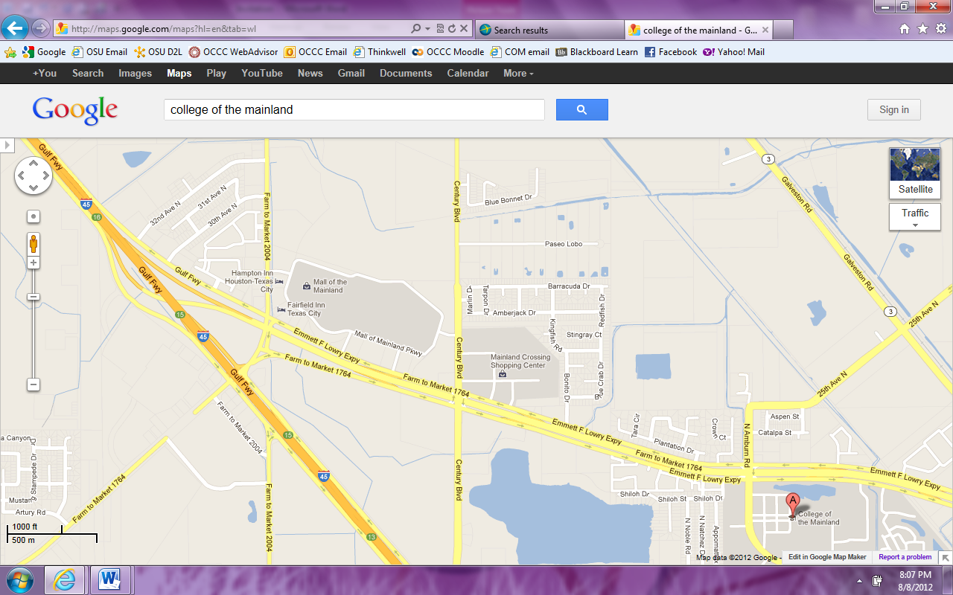

**Awards**

* See point calculations above for team awards
* *Team Sweepstakes Awards* – to the top three (3) programs
* *Per Centum Award* – to the team with the highest winning percentage of all entered competitors for a program; minimum of four (4) entries
* *Top Community College Team Award*
* *Debate Awards* – to all elimination round competitors
* *Speaker Awards* - to the top five (5) speakers in each division
* *Judging Award* – to the top judge throughout the tournament

**Directions**

**Direction to College of the Mainland:**

* Traveling South on I-45, take the Emmett F. Lowry Expressway exit (Exit 16) on the right (see map above).
* Follow the Emmett F. Lowry Expressway (FM 1764) into Texas City.
* Take the Amburn Rd. exit on the right.
* Turn Right onto Amburn Rd.
* Take the first Left available entrance into campus to Parking Lot A (see campus map below)

**Parking:**

* There is no charge for parking and no parking permit required.
* Parking Lot A (as shown below) allows the easiest access in and out of the campus.
* Do not pull through the parking spaces facing incoming traffic; park in the direction of the parking spot or you may receive a parking ticket!

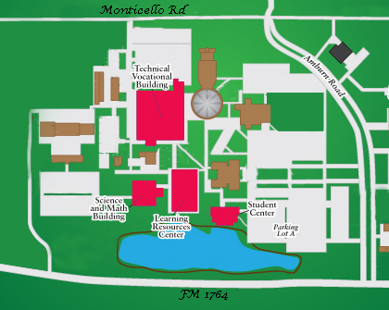

**Schedule**

|  |  |
| --- | --- |
| **Friday** | |
| 12:15-1:00 | Registration |
| 1:00-2:30 | Round 1 |
| 2:30-4:00 | Round 2 |
| 4:00-5:30 | Round 3 |
| 5:30-7:00 | Round 4 (dinner served) |
| 7:00-8:30 | Round 5 |
| 8:30-10:00 | Round 6 |

|  |  |
| --- | --- |
| **Saturday** | |
| 8:00-9:30 | Round 7 |
| 9:30-11:00 | Round 8 |
| 11:00-12:30 | Round 9 |
| 12:30-1:45 | LUNCH BREAK/Coaches’ Check |
| 1:45-2:30 | Awards |
| 2:30-3:30 | Elimination 1 |
| 3:45-4:45 | Elimination 2 |
| 5:00-6:00 | Elimination 3 |
| 6:00-7:00 | Elimination 4 (if needed) |

|  |  |
| --- | --- |
|  | **Duck Debates**  **March 6-7** |

Entries must be received by **4 PM**, Tuesday, March 3, 2015.

Fees for changes to entries assessed after **4 PM**, Wednesday, March 4, 2015.

E-Mail all registration forms to [debate@com.edu](mailto:debate@com.edu)

Make check payable to **College of the Mainland Pi Kappa Delta**

|  |  |  |  |
| --- | --- | --- | --- |
| **School Name:** |  | **Phone #:** |  |
| **Contact Name:** |  | **E-Mail:** |  |

|  |  |  |  |
| --- | --- | --- | --- |
| **Judge** | **Competitor Name** | **Division** | **Fee** |
|  |  |  |  |
|  |  |  |
|  |  |  |
|  |  |  |
|  |  |  |  |
|  |  |  |
|  |  |  |
|  |  |  |
|  |  |  |  |
|  |  |  |
|  |  |  |
|  |  |  |
|  |  |  |  |
|  |  |  |
|  |  |  |
|  |  |  |
| **Late Entry Changes** |  | |  |
|  |  | **Total Due** |  |