2016 University of Tennessee- Knoxville
February 10th – 12th, 2016 − University of Tennessee, Knoxville

Esteemed Debaters,
The Tennessee Speech and Debate Society of the University of Tennessee at Knoxville is honored to extend an invitation to you and your debate team to attend the University of Tennessee’s VOL Classic on February 10th-12th, 2016.
We will be offering both Team IPDA (TIPDA) and all four divisions of IPDA. We are looking forward to a well-run, enjoyable tournament. We hope to offer you a fun and enjoyable tournament for any debate level. Anthony Fruscione and assistant Samantha Izzi will be running the tab room.
Pre-tournament updates will be sent via email and Facebook (a tournament group page will be created closer to the event).
If you have any questions, please feel free to contact us by email or by phone. We look so forward to seeing you!
Warm regards,
Tennessee Speech and Debate Society

CONTACTS:
Denizhan Pak, President Mickayla Stogsdill, Secretary
(931) 998-0048 (316)708-8261
dpak1@vols.utk.edu mstogsdi@vols.utk.edu

ENTRY DEADLINES
All teams must correspond their intent to participate by 5:00 pm Monday, February 6th, 2016 to utkdebateteam@gmail.com
Any changes must be made by 5:00 pm Wednesday, February 8th, 2016. Any changes after this deadline will warrant a charge of $15.

Hotels
Hotels options are conveniently placed in downtown and immediately surrounding campus areas. Below is a list of nearby hotels:

Hilton Garden Inn (1706 Cumberland Avenue, Knoxville, Tennessee 37916)- (865) 437-5500
Holiday Inn (525 Henley Street Knoxville, Tennessee 37902)- (865) 522-2800
The Oliver Hotel (407 Union Ave SW, Knoxville, TN 37902)- (865) 521-0050
Red Roof Inn (1315 Kirby Rd, Knoxville, TN 37909)- (865) 584-3911
Travelodge (6200 Papermill Dr NW, Knoxville, TN 37919)- (865) 584-8511

Arrival and Registration
Registration will be on the third floor in the Stokley Management building in room G2. Like many universities, our room selections will not be finalized till closer to the tournament, and we will email any more details we have as soon as we have them a couple of days before the tournament. Below is a map of most of campus. 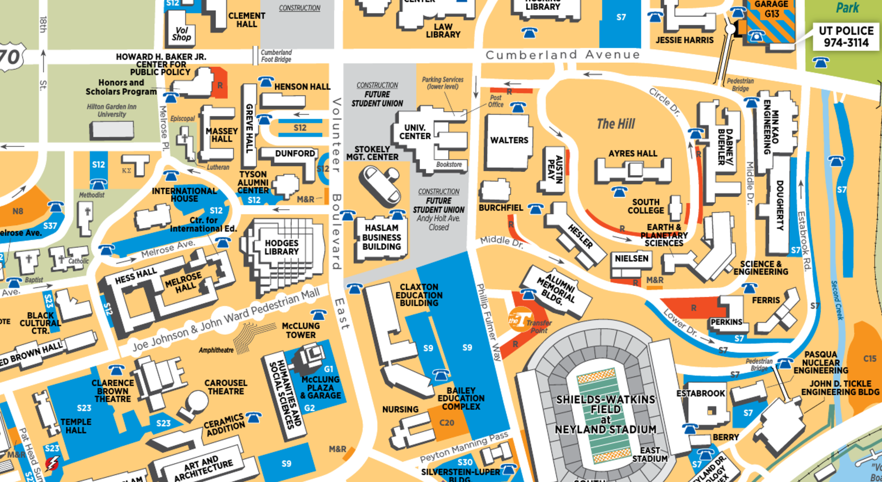
NOTE: Participants/teams/judges not showing up to their rounds is equivalent to an entry being dropped at registration. Thus, please be sure your students and judges attend each of their assigned rounds.

Parking:
Parking permits will be distributed at registration.

Schedule (May be subject to minor changes)
Friday February 10, 2016
1:30 Registration
3:30 Draw Round 1 Team
5:00 Draw Round 2 Team
6:30 Draw Round 3 Team
8:00 Draw Round 4 Team
9:30 Coaches Check

Saturday February 11, 2016
8:00 Team Quaters
9:30 Team Semis
ASAP Team Finals
11:00 Registration: IPDA only
12:30 Draw Round 1
2:00 LUNCH! Free Food (if there are dietary restrictions, please let us know with your entry form)
3:30 Draw Round 2
5:00 Draw Round 3
6:30 Draw Round 4
8:00 Draw Round 5
9:30 Draw Round 6

Sunday February 12, 2016
8:30 Coaches Check
9:00 Postings
9:30 Draw 1st Elimination Round
11:00 Awards Ceremony
ASAP All other elimination rounds

Fees
IPDA ……………………………………….………………………………………………….25$ per head
TIPDA……………….…………………………………………………………..……………40$ per team

Judges
IPDA ……………………..…………….……………….……………………1 judge for every 4 heads
TIPDA…………………………………………………...…………………………..1 judge per 2 teams
JUDGE FEES (for every uncovered debate slot)…………………………………..…………15$

PLEASE BRING JUDGES
Judging will be tight!

Food Provided
SNACKS FOR JUDGES…………………………………….Throughout the Tournament
MEALS……………………….……………………….………………………………Lunch on Saturday
PAYMENT
CASH OR CHECKS ONLY. Make all checks payable to the Tennessee Speech and Debate Society.

SWEEPSTAKES AND AWARDS
Sweepstakes will follow the following formula: All wins and byes will be awarded
1 point. Each person breaking to out-rounds will receive 2 points. Speaker awards
will count toward sweepstakes points with 1st – 5 points; 2nd – 4 points, 3rd – 3
points; 4th – 2 points, 5th – 1 point; Novice, Junior Varsity, Varsity and Professional
will count toward the tournament sweepstakes. There is no limit on entries, but
only the top three competitors in each division will count toward the sweepstakes. There will be speaker awards for the top 5 competitors from each division in both IPDA and TIPDA, sweepstakes for IPDA, and overall sweepstakes for TIPDA and IPDA. The team with the highest winning percentage (minimum 3 competitors) will also receive the “Big Orange.”

Entry Form

School:
Coach:
Address:
Office Phone:
Email:

IPDA
Novice Division: 1.
2.
3.
4.
5.
Junior Varsity Division:
1.
2.
3.
4.
5.
Varsity Division:
1.
2.
3.
4.
5.
Professional Division:
1.
2.
3.
4.
5.
Judges:
1.
2.
3.
4.
5.
Fees:
______ competitor slots @ $25 each = ______

TIPDA
Teams:
1.
2.
3.
4.
5.
Judges:
1.
2.
3.
4.
5.
_________ competitor slots @ $40 per team = ____________

(Please Make Checks Payable To: Tennessee Speech and Debate Society)
Entries can be emailed to Denizhan Pak and Mickayla Stogsdill at utkdebateteam@gmail.com

