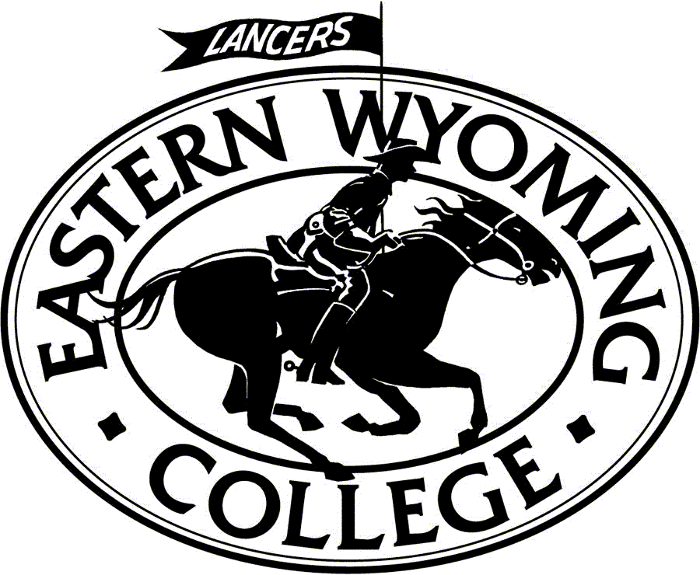
August 24, 2016
Dear Colleagues,
We welcome you to the First Annual Lancer Invitational and Cougar Swing, co-hosted by Eastern Wyoming College and Colorado Christian College on the EWC campus in Torrington, Wyoming October 7-9.
The tournament will offer five preliminary rounds of International Public Debate Association (IPDA) style debate with two divisions, novice and varsity, with an appropriate number of elimination rounds as proscribed by the IPDA charter. Debate will begin on Friday and conclude Saturday. The Lancer Invitation will also offer two preliminary rounds of AFA individual events on Saturday with appropriate elimination rounds. The Cougar Swing, held Sunday, will offer two preliminary rounds of all AFA events with appropriate elimination rounds.
As this is the first year of the tournament, we are asking for a little earlier submission deadline than is traditional. All entries must be sent to Jeremy Christensen by October 3, 2016. Please fill out the attached form.
To keep the tournament running on time, and to ensure the wellness of the debaters, the tournament will offer a pizza dinner on Friday evening and Subway sandwiches for lunch on Saturday (please indicate dietary restrictions on the entry form.) To defray the costs, we are adding a $10.00 per person tournament fee to cover dinner and lunch.
We are excited to see you October 7, and look forward to a great season.

Sincerely,

Jeremy Christensen Dr. Chris Leland
Instructor of Communication Professor of Communication
Director of Forensics Director of Debate
Eastern Wyoming College Colorado Christian University
Office Number: (307)532-8367 Office Number: (303) 963-3479
Cell Number: (307) 575-6972 cleland@ccu.edu
jeremy.christensen@ewc.wy.edu

Lancer Invitational Schedule
Friday October 7, 2016
3:00- 3:50 Debate Registration Auditorium
4:00 IPDA Round I Topic Draw
4:30 IPDA Round I begins
5:15 IPDA Round II Topic Draw
5:45 Round II begins
6:15 Dinner Served (Pizza)
6:45 Round III Topic Draw
7:30 Round III begins (Powered off 1 and 2)
8:15 All ballots from Round III due at the ballot table

Saturday, October 8, 2016
8:00 A.M. Round IV Topic Draw
8:30 A.M. Round IV begins
9:15 A.M. Round V Topic Draw
9:45 Registration for Individual Events Only
9:45 A.M. Round V Begins
10:30 Flight A (Round I)
11:30 Quarterfinals IPDA
12:30 Flight B (Round I)
1:30 Lunch
2:00 Flight A (Round II)
3:00 Semifinals IPDA
4:00 Flight B (Round II)
5:30 Finals All Events and IPDA Finals
6:45 Awards
Cougar Invitational
Sunday, October 9, 2016
7:30 A.M. Registration
8:00 A.M. Flight A (Round I)
9:30 A.M. Flight B (Round II)
11:00 A.M. Flight A (Round I)
12:30 P.M. Lunch
1:00 P.M. Flight A (Round II)
2:30 P.M. Flight B Finals
4:00 P.M. Flight A Finals
5:30 P.M. Awards
Entry Costs and Methods
Debate:
The cost for each IPDA entry is $25.00 for a covered entry. Uncovered entries are an additional $25.00 for each debater.

Individual Events:
Individual events entries will be $10.00 each and one judge covers six entries. For AFA requirements the judge should be a college graduate or a member of your larger community and not a student. Please keep that in mind when you fill out the entry form.
Each uncovered entry will be assessed an additional $10.00.
Flight A: EXT, PERS, DUO, POI, CA, DI
Flight B: PRO, INF, IMP, POE, ADS
All persons in the pool as judges and/or competitors are required to judge one round past their squad’s last round.
Lastly, the tournament needs to go forward on time. Students will be allowed a two minute grace period in IPDA before they forfeit the round. For individual events, competitors are expected to sign in and proceed quickly and efficiently between rounds. All rounds will begin as scheduled, so judges will be asked to leave their rooms once the next round is set to begin.
All individual events judges are required to adjudicate both Flight A and Flight B Finals.

Please make checks payable to Central Wyoming College.
Judging
As IPDA is a public forum, we would ask, if possible, that you bring someone from your administration, faculty, or even a prospective debater from a class to judge. The IPDA rules do not require that the judge has a bachelor’s degree, and IPDA style debate, unlike NPDA, does not reward jargon, specialized delivery, or practices often articulated in most current debate formats.
Individual events, on the other hand, requires the judges be members of the community, administration, and/or former students.
All debaters and debate judges are committed through quarterfinals or one round beyond their squad’s participation in elimination rounds. All individual events judges are expected to judge through finals of both flights, regardless of their squad’s outcome.
Lodging
A block of rooms for the nights of October 8 and 9 has been set aside at the Holiday Inn Express in Torrington at the following rates:
12 Double Queen $89.00 per night
11 Junior Suites $120.00 per night (king bed with a pull-out couch)
6 King $89.00 per night.
The hotel offers breakfast and free wi-fi.
If you are interested call them at (307) 532-7600 and ask for the Lancer Invitational Tournament block. The block expires September 14, 2016.
You might also consider the following options:
America’s Best Value Inn
1548 S. Main Street
Torrington, WY 82240
(307) 532-7118
The Days Inn
1555 Main Street
Torrington, WY 82240
(307) 532-4011

Parking and Map
The main campus of Eastern Wyoming College is located in Torrington, Wyoming, and is located at 3200 West C Street. When approaching the campus from the south, you will come up a steep hill and note a sign to turn in for cosmetology and welding programs, you may turn in there and park in that area or you may proceed to the next entrance and park in that lot. If you are bringing a shuttle bus, please let me know and I will give you the directions for parking, as EWC has a specific lot designated for that event.

Here is a link to the campus map:
Awards
Lancer Invitational
All elimination round participants will receive awards, with substantive awards (trophies) for 1st-3rd place.
Pentathlon Awards will be given to the top three competitors who compete in five individual events.
The Lancer All-Around Award will go to the top competitor whose record is best in both debate and at least two individual events.
Sweepstakes Awards: A first, second, and third place award will go to the top three colleges based upon cumulative results of debate and individual events. The process for awarding sweepstakes will consider the top three competitors in each event. The matrix for tabulation will be provided in your tournament packet.
EWC competitors are eligible for all awards, except sweepstakes and the Lancer All-Around.
Accommodations
Should you or a member of your team need special accommodations, please ask. We are happy to help make the experience as enjoyable as possible.

Lancer Invitational Debate Entry Form
Debater’s Name Division: (N)ovice or (V)arsity
1. ___________
2. ___________
3. ___________
4. ____________
5. ____________
6. ____________
7. ____________
8. ____________
9. ____________
10. ____________

Lancer Invitational and Cougar Swing
Individual Events Entry
Place an “X” in the box that corresponds with the students’ entries. In the “Tournaments” Box indicate “1” for Lancer Invitational only “2” for Cougar Swing only and “3” for both the Lancer Invitational and Cougar Swing

Name: First and Last | EXT | PERS | DUO | POI | CA | DI | PRO | INF | IMP | POE | ADS | Tournaments
Name | EXT | PERS | DUO | POI | CA | DI | PRO | INF | IMP | POE | ADS | TOURNAMENTS

Students/Faculty with dietary restrictions
1.

2.

3.

4.

5.

Cost Worksheet

Debate Entries ________ X $25.00
Uncovered debate entries X $25.00

Total Cost of Debate Entries $__________

Individual Events Entry_______ X 10.00
Uncovered Individual Events Entries_______X 10.00

Total cost of individual events entries X __________ tournaments

Tournament Fee for Lancer Invitational $10.00 X _________ persons with the squad. (Include judges and competitors) = __________ total tournament fees.

Total Cost________________

